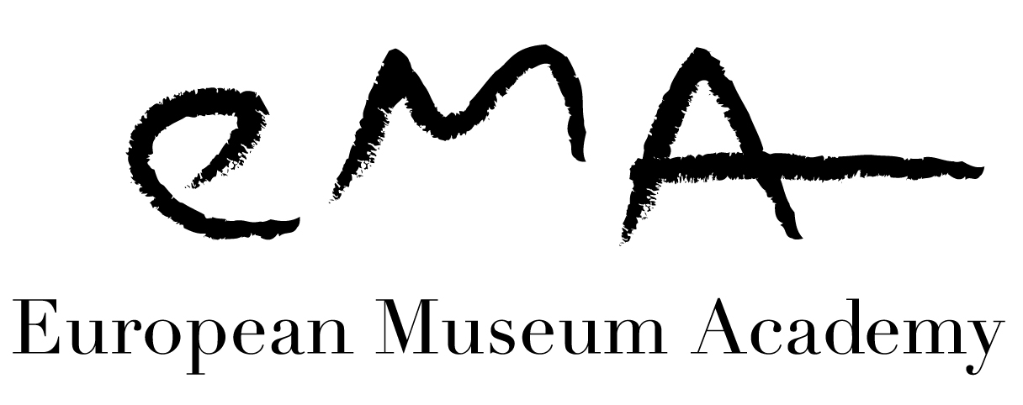
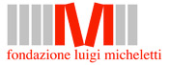

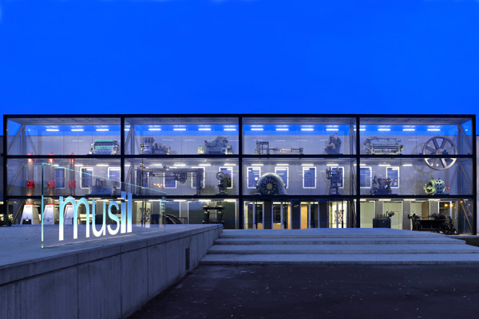
APPLICATION FOR THE 2015
LUIGI MICHELETTI AWARD

THE MICHELETTI AWARD
musil – Museum of Industry and Labour (Brescia, Italy)
PUT YOUR MUSEUM CENTRE STAGE!

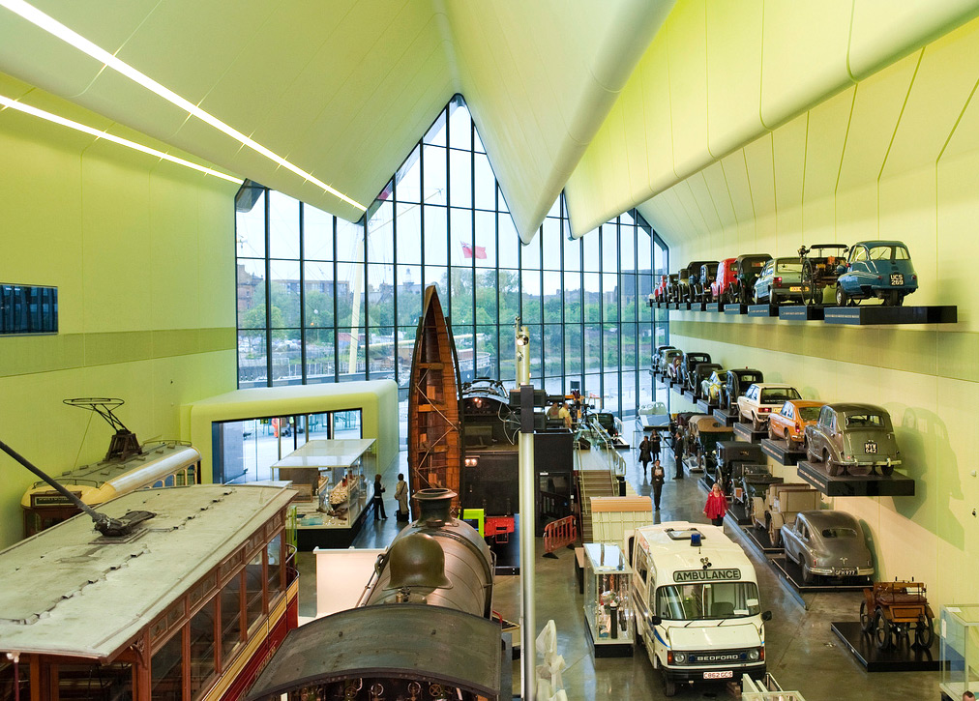
This is an Award focused on contemporary European history and its scientific, industrial and social heritage. You may apply if you are a museum of 20th-century history (social, political, military), a museum of science, technology or industry, a science centre, an ecomuseum or an interpretation centre on these subjects.
Riverside Museum
(Glasgow, UK),
LMA 2012 Winner

THE MICHELETTI AWARD
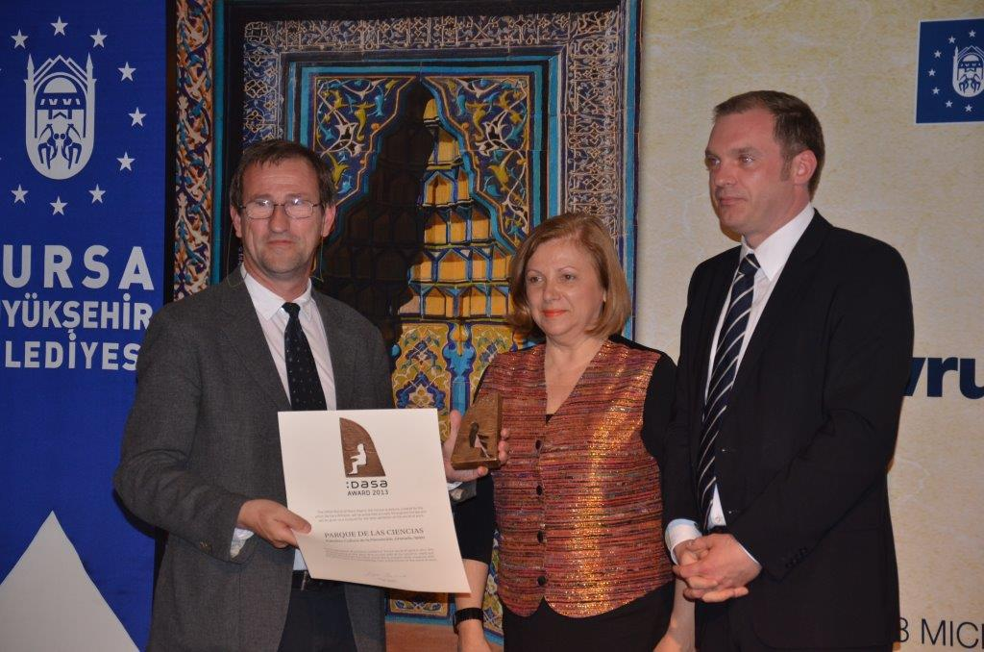
TODAY’S EUROPEAN MUSEUM EXPERIENCE!

Apply right now, don’t miss the chance to profit from the visibility and networking opportunities offered to your museum by taking part in the scheme. Hundreds of museums have already done so in the 19 years of activity of the Micheletti Award.
Mr Ernesto Páramo Sureda, Director of the Parque de las Ciencias, Granada, Spain, winner of the 2013 DASA Award, with Dr Andreja Rihter, EMA President and Dr Gregor Isenbort, Director of DASA, Dortmund.

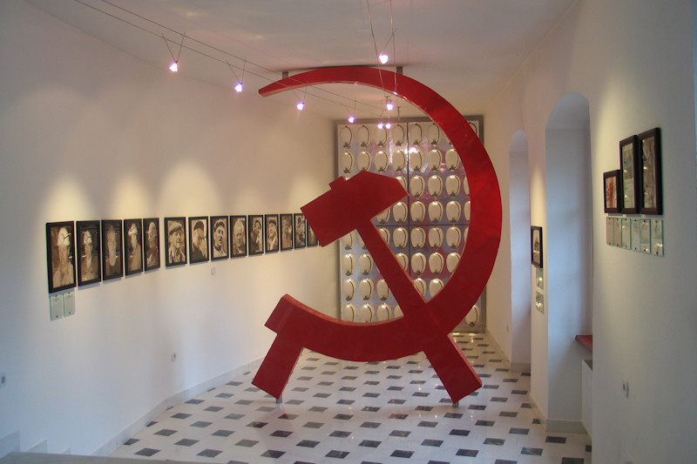
European Museum Academy
A European Museum Expertise Foundation

Kanaalweg 46, 2584 CL, The Hague – The Netherlands
Chairman’s office: Tel.0031 703515160; Director’s office: Tel. 0039 0289775567
E-mail: europeanmuseumacademy@gmail.com;
www.europeanmuseumacademy.eu
Registration number: 27359130 Chamber of Commerce, The Hague
Idrija Municipal Museum (Idrija, Slovenia), LMA 1997 Winner

ENTRY DATA

Name of museum …………………………………………………………………………………………
Director ……………………………………………………………………………………….…………...
Full postal address ………………………………………….................................................................
……………………………………………………………………………………………………..…………..
Telephone/fax numbers, with area code……………………………………………..………………...
E-mail and website ……………………………………………….…………………………….………
Type of museum/historic site/naturalistic site………...………………………………………………...
Finance: public or privately financed?…………………………………………………………………..
Number of objects ……………………………………………………………………………………...
Exhibition and storage spaces (in m²): ……………………………………………..…………………..
Number of permanent employees ……………………………………………………………………...
Number of temporary employees or volunteers ………………………………………………………..
Opening times ……………………………………………………………………………………….…
Number of visitors in 2013……………………………………………………………………………...
What aspect of your museum makes it a strong candidate for this Award?

…………………………………………………………………………………………………………………
…………………………………………………………………………………………………………………
……………………………………………………………………………………………………….………..
……………………………………………………………………………………………………..………….
…………………………………………………………………………………………………………………
…………………………………………………………………………………………………………………

…………………………………………………………………………………………………………………

…………………………………………………………………………………………………………………

…………………………………………………………………………………………………………………

The closing date for applications is 15 September 2014. It would be very helpful if you could notify us of your intention to apply before despatching your material.
Completed forms and supplementary material should be sent to
Ann Nicholls, EMA Co-ordinator, 17 Woolcot Street, Redland, Bristol, BS6 6QH, UK.
Tel +44 (0)117 973 7965. ann.n1403@gmail.com; europeanmuseumacademy@gmail.com; www.europeanmuseumacademy.eu.

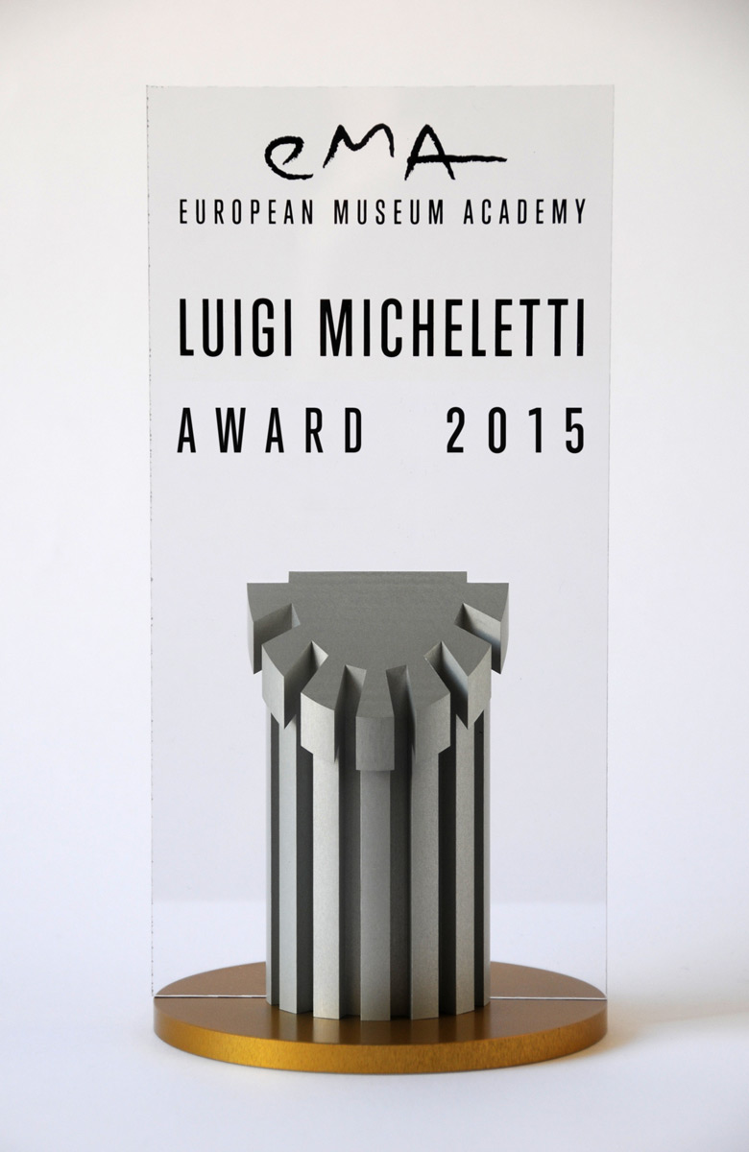
ENTRY FEE

The completed application should be accompanied by an entry fee of
200 € (two hundred Euros), paid by bank transfer. Transfer charges must be paid by the applicant. Please make sure that your payment can be identified and include a copy of the transfer instructions with your application.

Bank: ING Bank
Account name: European Museum Academy
IBAN: NL36INGB0004682823
BIC: INGBNL2A

SUPPORTING MATERIAL

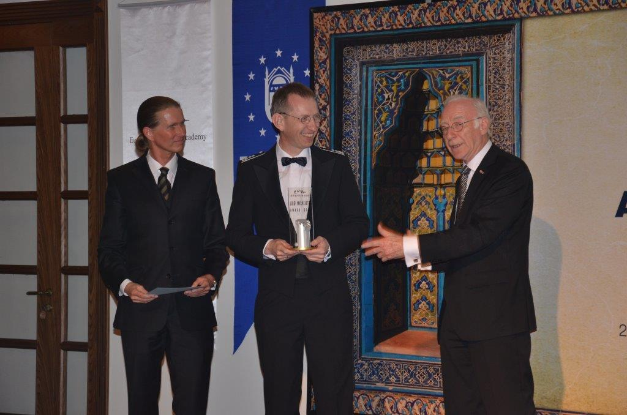
The completed application form to be accompanied by two copies of a CD which should include:

- Two typewritten pages (Word format) in English describing the museum, its organisational structure, its method of financing and the European relevance or innovative aspects and/or of the museum’s treatment of the industrial, technical or scientific heritage, or of 20th century military, political and social history.
- Up to 20 digital images, 300 dpi in JPEG format, with one exterior, general views of the exhibitions and pictures which illustrate your strong candidature for the Award, pictures must be free of copyright and accompanied by a declaration which enables EMA to use them for non-commercial purposes in its printed materials, on the Internet as well as in training programmes.
Dr Gorch Pieken and Dr Matthias Rogg (Director)
of the Militarhistorisches Museum der Bundeswehr in Dresden, Germany, receiving the 2013 Micheletti Award from Dr Wim van der Weiden,
EMA Chairman in Bursa, Turkey

- Scanned copies of a brochure, leaflet or other publicity material you wish to include (please do not send paper copies!).
- A copy of the bank transfer instructions.

Note: it is not possible to return disks after the judging has taken place
THE EUROPEAN MUSEUM ACADEMY
EMA is a non-profit Foundation established to reflect museums at the international level, to promote research on museography and museology as a high cultural activity, to provide constructive criticism and promote discussion on new exhibitions and museums, and to diffuse museological knowledge and ideas among members of the profession. It aims to promote the conception and development of new as well as of traditional museums as tools of social change. The Micheletti Award is organised to illustrate best museum practice, in co-operation with the Micheletti Foundation, Thirty-one countries are currently represented within the EMA organisation. www.europeanmuseumacademy.eu.

THE LUIGI MICHELETTI FOUNDATION (Fondazione Biblioteca Archivio Luigi Micheletti) LMF (established in 1981 in Brescia) is a research centre specialising in 20th-century history. Scientific research covers ideologies of the 20th century, wars, the ambivalence of technical progress, industrialization and labour, conspicuous consumption, the origin of environmentalism. The ideological, social and material contemporary history, led by international researches and conferences, is linked to a rich collection: writings, postcards, photos, posters, videos, audio documents, but also objects, furniture and machines. It is in this context that the musil – Museum of Industry and Labour – was created, in order to focus on the recovery of productive plants and whole urban areas.www.fondazionemicheletti.eu; www.musilbrescia.it; www.luigimichelettiaward.eu; www.luigimichelettiaward.eu

